Draft Statement of Common Ground
Brockley Hill, Stanmore – New Banqueting Facility

Relating to site at
Former Stanmore and Edgware Golf Centre, Brockley Hill
27 September 2022
WORK IN PROGRESS

Contents
1.0 Introduction 3
2.0 Appeal Site and Surroundings 4
3.0 Planning History 8
4.0 Appeal Proposal 9
5.0 Pre- and post-application meetings and discussions with the Council 11
6.0 Planning Policy Framework 15
7.0 Areas of Agreement 18
8.0 Common Ground Matters Sought 27
9.0 Areas of Disagreement 28
10.0 Signatures 30

Appendices

- Photographs of the Appeal Site prior to the fire
- Photographs of the Appeal Site at May 2022
- Email from the Council’s Infrastructure Engineer (16th July 2021)
- Email from the case officer (18th June 2021)

- Introduction
  - This Statement sets out common ground between Sairam (Holdings) Ltd (“the Appellant”) and the London Borough of Harrow (“the Council”) in respect of the Appellant’s appeal against the Council’s refusal of planning application reference P/3088/20 on 26th November 2021. The application proposes the development of a new banqueting facility at the former Stanmore and Edgware Golf Centre, Brockley Hill, Stanmore, HA7 4LR (“the appeal site”).
  - The full description of the proposed development as cited on the decision notice issued by the Council is:
“Demolition of existing golf club buildings and construction of a single and two storey building for a banqueting facility, widening of existing vehicular access from Brockley Hill, car and cycle parking, waste / recycling storage, landscape enhancements and associated works.”
  - The application was validated on 1st September 2020. The application was considered at planning committee on 30th June 2021 where Councillors voted to defer the application to enable the Appellant to provide additional information. The application was then considered again at planning committee on 17th November 2021, where Members resolved to accept the case officer’s recommendation for refusal and added an additional reason for refusal in relation to the design and form of the proposed building.
  - This Statement of Common of Ground has been prepared by the Appellant in consultation with the Council.
Procedural Note
  - The Council’s Decision Notice cites three reasons for refusal; two reasons of refusal have been numbered as ‘2’. Therefore, within this Statement of Common Ground, the ‘transport’ reason which is listed as the third reason for refusal will hereon be referred to as ‘reason for refusal 3’.

- Appeal Site and Surroundings
Location and Surroundings
  - The Appeal Site is located within the administrative area of the London Borough of Harrow. The location and extent of the Appeal Site is identified by the red line boundary in Figure 1 below.
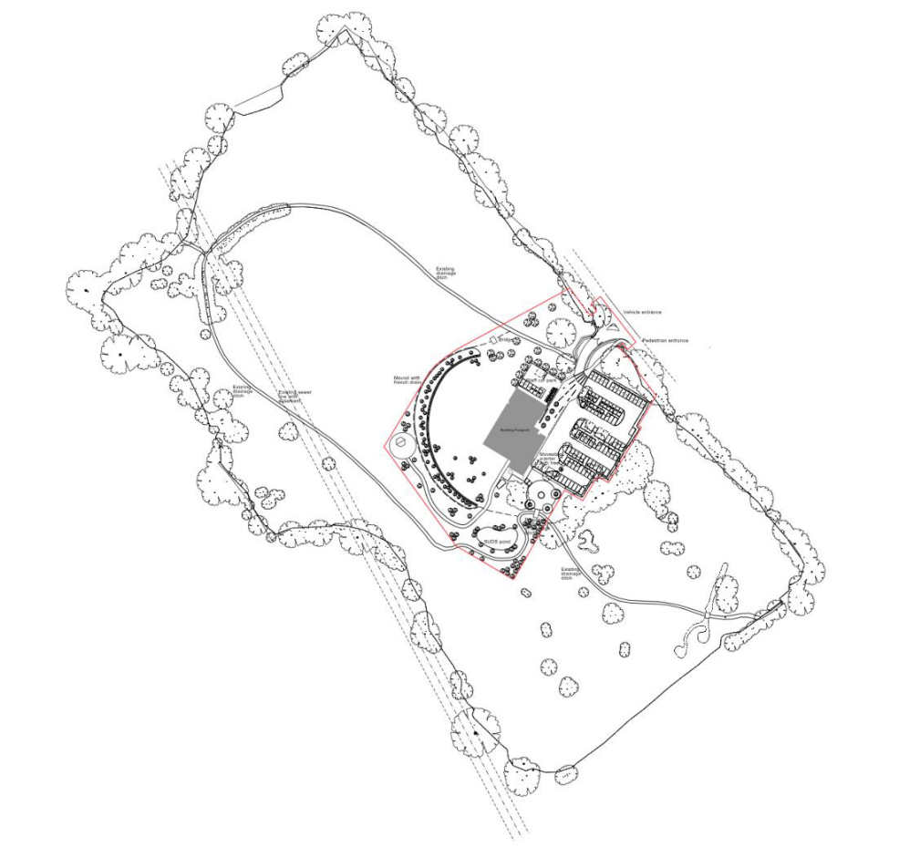
Figure 1: Appeal Site Location Plan

  - The Appeal Site is located in Stanmore, 1.3 km to the northeast of Stanmore Town Centre. The Appeal Site covers a total area of 1.63 ha and is located to the west of Brockley Hill (A5).
  - The Appeal Site contains the remains of the former golf centre building (Use Class D2) (following a fire in late June 2020), a storage building, car parking area and other areas of hardstanding associated with the former golf centre.
  - Prior to the fire, the golf centre building was part single storey, part 2 storeys in height. Photographs in Appendix 1 shows the clubhouse building and surrounding area prior to the fire.
  - In June 2020, the building was damaged by a fire. As shown in the photographs at Appendix 2, the original steel structure and some parts of the brick elevations and blockwork walls of the original building remain along with an area of hardstanding.
  - The photographs in Appendix 2 also show the current condition of the site. Since the fire, the site and surroundings have been subject to extensive vandalism and fly tipping. Graffiti has been drawn over a large part of the building and there are large piles of fly-tipped rubbish and debris from the fire.
  - Due to the remains on the site, which do not blend into the landscape, the site comprises previously developed land within the Green Belt.
  - Vehicular and pedestrian access is from Brockley Hill and is located towards the east of the former golf building, roughly midway between the junction with Wood Lane to the north and the A410 (London Road/Spur Road) to the south. Since the closure of the golf course and driving range in late 2019, the site has not been accessible to members of the public.
  - The wider site comprises a former 9-hole par-3 golf course and driving range. The golf course effectively wraps around the driving range which takes up most of the centre of the wider site. This wider site (including the area of the golf course) was originally included within the delineation of the application site when the application was submitted in August 2020. In a revised submission in January 2021, the site boundary was redrawn around the reduced area shown in Figure 1 above.
  - Approximately 125m south of the wider site (and circa 285m south of the golf course building) are a number of residential properties on Cleopatra Close and Augustus Close which form the northern part of the residential area to the south, and the edge of the built-up area of Stanmore. Cleopatra Close Park is also located directly south of the wider site and north of the residential properties.
  - Land to the north and west of the wider site is surrounded by Stanmore Country Park.
  - The London Borough of Barnet adjoins the site to the east, with the borough boundary running along Brockley Hill. Brockley Hill is under the jurisdiction of the London Borough of Barnet.
  - The Appeal Site is also approximately 700m south-west of the Royal National Orthopaedic Hospital (RNOH) campus.
Planning Designations
LB Harrow
  - The adopted Harrow Policies Map (extract in Figure 2) shows the Appeal Site to be within (i) the Green Belt; (ii) the Harrow Weald Ridge Area of Special Character; and (iii) the Stanmore and Harrow Weald Core Strategy Sub Area.
  - A small area immediately to the north of the golf centre building lies within Surface Water Flood Zone 3a/3b.
  - The Appeal Site is also partially located within an Archaeological Priority Area that forms a strip of land that runs through part of the car park and the side of the golf course adjacent to Brockley Hill.
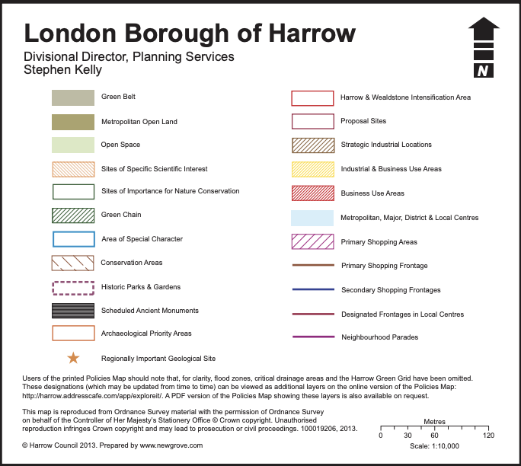
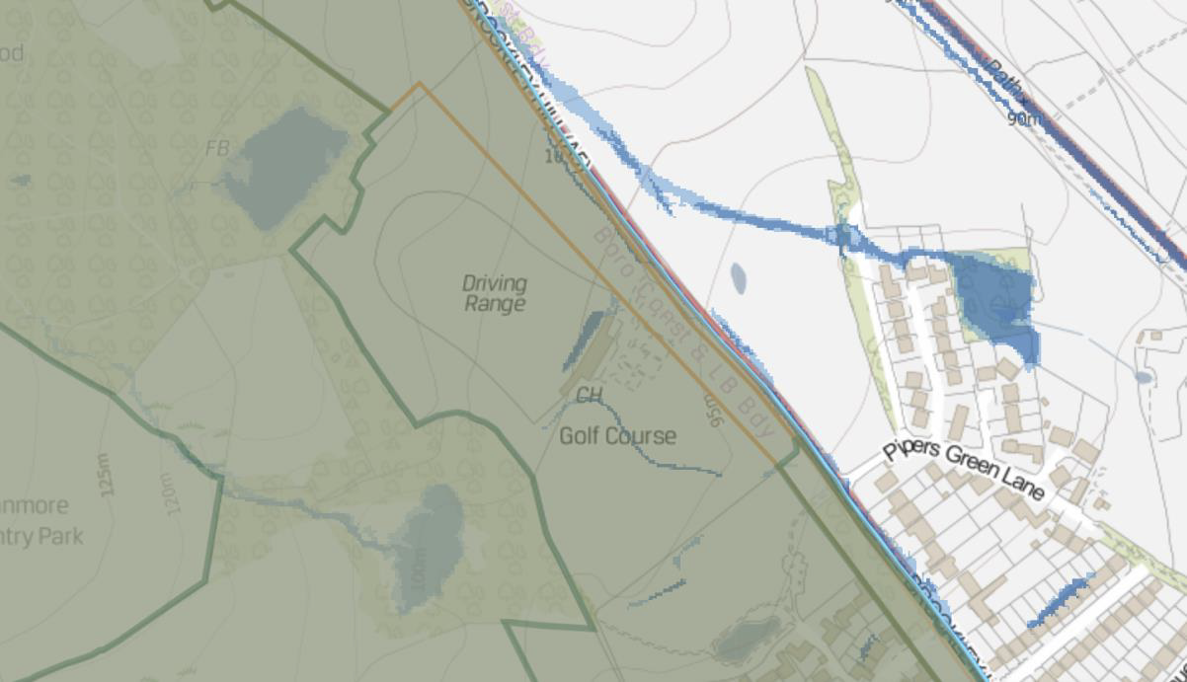

Figure 2: Extract of Harrow's planning policies map

Other Relevant Designations
  - The Appeal Site has a PTAL rating of 1a (see Figure 3). The nearest bus stop to the site is located to the south on Brockley Hill, approximately 300m away. The bus stops are served by the 107 bus service between New Barnet and Edgware via Elstree and Borehamwood. The site is located some 1,500m when travelling on foot or in a vehicle from Stanmore Tube Station which provides regular services on the Jubilee Line into Central London with an interchange at Wembley Park.
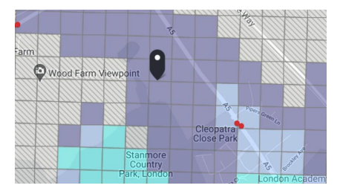
Figure 3: Extract from TfL Planning Information Database

  - The site is well connected by car to both the A1 and M1, with access from A5 Brockley Hill.
  - The Environment Agency’s Flood Map for Planning shows the Appeal Site is also located within Flood Zone 1 (Figure 4).
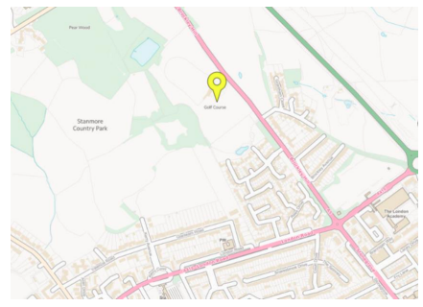
Figure 4: Extract from the Environment Agency’s Flood Map for Planning

- Planning History
  - A summary of the relevant planning history if set out in Table 1 below.
Application Ref | Description of Development | Status and Date of Decision
P/1525/17 | Change of use from a golf driving range with ancillary golf shop and first floor flat (Class D2) together with two storey rear extension and external alterations to nine flats (Class C3); Single storey detached building at side for use as replacement golf reception building; provision of parking, refuse and cycle facilities. | Refused 30/1/2018  Allowed on appeal (APP/M5450/W/18/3201017), dated 23/8/2018
P/3036/20 | EIA Screening Opinion to determine whether an Environmental Impact Assessment is required for demolition of the existing golf club (Use class D2) and construction of a new banqueting facility (Use class D2); widening of vehicle access; car and cycle parking; waste/recycling storage; landscaping; associated works | Environmental Impact Assessment not required – 10/9/2020

Table 1: Relevant planning history
  - The appeal decision (ref: APP/M5450/W/18/3201017) confirms that the golf centre building, together with its adjacent storage areas and car park, constitute previously developed land as defined in the NPPF (paragraph. 11 of appeal decision):
“On the evidence before me, there appears to be no disagreement between the parties that the golf centre building, together with its adjacent storage areas and car park, constitute previously developed land as defined in the Framework.”

- Appeal Proposal
  - This appeal concerns the following proposal:
“Demolition of existing golf club buildings and construction of a single and two storey building for a banqueting facility; widening of existing vehicular access from Brockley Hill, car and cycle parking, waste/recycling storage, landscape enhancement and associated works”
  - Full details of the appeal scheme are contained in the Planning Statement (August 2020), Supplementary Planning Statement (January 2021), Design and Access Statement (August 2020) and Supplementary Design and Access Statement (January 2021) with a summary set out below.
Proposed Development
Design
  - The proposed building comprises three distinct elements forming:
- Front of house: one and a half storey (with accommodation in the roofspace);
- Back of house: single storey; and
- Banqueting hall: single storey.
  - The proposed building would have a GIA of 1,458 sqm, a maximum height of 9 metres, a width of circa 43.4 m and a depth of circa 31.3 m, extending to a maximum width of 46.5m and depth of 32.4m including all roof overhangs and ancillary external elements such as the spiral staircase.
  - The main access into the building would be through the ground floor eastern elevation of the front-of-house building, which contains a reception area and WCs. A smaller function hall, two meeting rooms and bridal suite are provided in the roofspace of the front-of-house building.
  - The back-of-house area would contain the main kitchen, storage areas, bin storage, plant areas and staff WCs.
Landscaping
  - Landscape improvements include the introduction of a formal lawn, new trees and hedgerows, new shrub and areas of wildflower planting, a front garden area and a pond.
  - The landscape enhancements will increase biodiversity on the site by 20%.
Access and parking
  - The proposals include the widening of the existing vehicular access, as well as prohibiting vehicles turning right into the site from the north on Brockley Hill.
  - The proposed speed limit on Brockley Hill would be reduced to 30 mph.
  - As originally proposed, the existing car park would be modified and would provide 78 spaces with an additional 6 staff spaces (84 in total). 14 spaces will have active (7) or passive (7) electric vehicle charging ports (EVCPs) and 4 disabled parking spaces. However, the Appellant’s latest proposal is that the existing car park would provide a total of 129 car parking spaces comprising: 93 standard spaces; 4 enlarged spaces; 7 disabled spaces; 5 staff spaces and 20 valet parking spaces.
  - There will be secure cycle storage for 21 bicycles, comprising 4 long stay and 17 short stay spaces.
Servicing, deliveries and refuse
  - A dedicated servicing and delivery area is proposed to the rear of the back-of-house element of the scheme which will contain the refuse and recycling bins.
Sustainable drainage
  - The scheme incorporates sustainable drainage measures including a pond to the south of the new front landscaped garden.

- Pre- and post-application meetings and discussions with the Council
Initial meetings with the Council during site finding process
  - During the process of finding a site for a replacement facility for Premier Banqueting, a number of discussions were held with the Council’s Regeneration team.
Pre-application discussions with the Council & GLA
  - The Appellant and consultant team undertook extensive pre-application discussion at meetings with senior officers at the Council (Case Officer, Team Leader and the Head of Development Management) and a presentation to the Council’s Design Review Panel. A Level 2 pre-application meeting was also held with officers at the GLA (Case Officer, Team Leader, Design and TfL Officers). Discussions were also held with Highways Officers at both the London Borough of Harrow and London Borough of Barnet.
  - These discussions shaped and informed the design proposals resulting in the appeal scheme.
  - A detailed summary of the various pre-application meetings and discussions and how this ongoing dialogue resulted in scheme amendments is contained in the Planning Statement (August 2020).

  - The above demonstrates the extensive and positive pre-application engagement by the Appellant and consultant team with officers, consultees and local stakeholder interests to inform substantial amendments to the scheme prior to the submission of the planning application.
Discussions with the Council post submission of the application
  - The planning application was submitted on 27th August 2020 and found to be valid on 1st September 2020. Following the submission of the application, a further party obtained an interest in some of the land within the planning application boundary. The planning application form was amended and an additional Certificate B was served on the new party with an interest in the land.
  - In January 2021, the Appellant submitted minor amendments to the scheme to address comments made by statutory consultees and to amend the planning application boundary and site area. Following this re-submission, the Council re-consulted on the planning application for a further 21 days.
  - Following the submission of additional information, the Council became aware through the Council’s planning policy team of an appeal decision at Lanbrook, St Mary’s Lane, Hertingfordbury, SG14 2LD (PINs ref: APP/J1915/W/20/3254917) where planning permission had been sought for a 5 bedroom, two storey detached house, following the complete demolition of the existing building after a fire.

  - The Council considered that the circumstances of this appeal case altered the basis for assessing the proposed banqueting scheme in the context of the fire-damaged building. The Council no longer considered it appropriate to determine the application in accordance with the exceptions criteria in paragraph 145 of the Framework (2019) and that very special circumstances needed to be demonstrated.
  - Following further consultation, the application was considered at the Council’s Planning Committee on 30th June 2021. The officer’s recommendation was to refuse the application for the following reasons:
- The applicant has failed to demonstrate that the proposed development would not have a greater impact on the openness of the Green Belt than the existing development on the application site. The proposed development would therefore constitute inappropriate development in the Green Belt, to the detriment of the character, appearance and openness of the Green Belt, contrary to the National Planning Policy Framework (2019), policy G2 of The London Plan (2021), Core policy CS 1 F of the Harrow Core Strategy (2012), and policy DM 16 of the Harrow Development Management Policies Local Plan (2013), and no very special circumstances have been demonstrated by the applicant whereby the harm by reason of inappropriateness is outweighed by other considerations.

- The proposed development, by reason of failure to provide adequate on-site or off site car / coach parking and lack of integrated drop off facilities to serve the proposed banqueting facility, would significantly intensify site usage and generated trips. The associated likely on site congestion and parking overspill into the London Borough of Harrow and the London Borough of Barnet, with particular reference to the residential streets to the south-east of the site, is therefore considered to be detrimental to highway and pedestrian safety, and the amenities of neighbouring occupiers, contrary to the National Planning Policy Framework (2019), Policy T4 of The London Plan (2021), and policies DM 42 E and F, DM 1 B (f) (C) and D (h), policy DM 42 E and F and DM 43 B and C of the Harrow Development Management polices Local Plan (2013).
- The proposed development by reason of inadequate archaeological evaluation of the application site, has failed to demonstrate that potential archaeological assets of significant importance would not be harmed and impacts minimised through appropriate design and construction. The proposal would therefore fail to comply the National Planning Policy Framework (2019), policy HC1 C and D of The London Plan (2021), policy CS1 D of the Harrow Core Strategy (2012) and policy DM 7 A, B and H of the Harrow Development Management Polices Local Plan (2013).
- The proposed development, in the absence of adequate Ecological Assessment which fails to address the sites strategic Green Belt location and the sites boundaries including its close proximity to the adjoining Pear Wood and Stanmore Country Park Site of Importance for Nature Conservation, fails to demonstrate that biodiversity value of the surrounding area would not be harmed, protected or enhanced, contrary to the National Planning Policy Framework (2019), policy G6 of The London Plan (2021), policy CS 1 E of the Harrow Core Strategy (2012) and policies DM 20 and DM 21 of the Harrow Development Management Polices Local Plan (2013).
  - Officers recommended an additional reason for refusal that was included on the Planning Committee Addendum dated 30th June 2021:
- The proposed development in the absence of the assessment which clearly shows that the existing sports and recreational land or facilities to be surplus to requirements for provision of alternative sports and recreational provision at the local and sub regional level taking into account the borough’s assessment of need, fails to comply with the National Planning Policy Framework (2019) and policy S5 of the London Plan (2021).
  - Members resolved to defer the planning application to allow the Appellant to submit additional information in respect of the proposed reasons for refusal (specifically, a Supplementary Landscape and Openness Assessment based on the fire-damaged building; a supplementary Planning Statement (including an Assessment of Sports Facilities; Parking Management Plan; Archaeological Evaluation; and an Ecological Technical Note). The information was required to be submitted by early August in order for the application to be considered at the early September 2021 Planning Committee meeting.
  - The Appellant requested an extension of time to prepare and submit the additional information given the need to undertake additional technical assessments. Members agreed to this request at the Council’s Planning Committee on 1st September 2021 and agreed to defer consideration of the application until the 17th November 2021 Planning Committee.
  - In September 2021, the Appellant submitted the requested additional information to the Council in respect of the proposed reasons for refusal.
  - The application was considered again at the Council’s Planning Committee on 17th November 2021 with an officer recommendation that the committee refuse the application for the following two reasons:
- The proposed development would have a greater impact on the openness of the Green Belt than the existing development on the application site. The proposed development would therefore constitute inappropriate development in the Green Belt, to the detriment of the character, appearance and openness of the Green Belt, contrary to the National Planning Policy Framework (2021), policy G2 of The London Plan (2021), Core policy CS 1 F of the Harrow Core Strategy (2012), and policy DM 16 of the Harrow Development Management Policies Local Plan (2013), and no very special circumstances have been demonstrated by the applicant whereby the harm by reason of inappropriateness is outweighed by other considerations.
- The proposed development, by reason of failure to provide adequate on-site or off site car / coach parking and lack of integrated drop off facilities to serve the proposed banqueting facility, would significantly intensify site usage and generated trips. The associated likely on site congestion and parking overspill into the London Borough of Harrow and the London Borough of Barnet, with particular reference to the residential streets to the south-east of the site, is therefore considered to be detrimental to highway and pedestrian safety, and the amenities of neighbouring occupiers, contrary to the National Planning Policy Framework (2021), Policy T4 of the London Plan and policies DM42 E and F, DM 1 B (f) (C) and (D) (h), policy DM42 E and F and DM43 B and C of the Harrow Development Management Policies Local Plan (2013).
  - Following discussion at the Planning Committee, members added an additional reason for refusal that related to the design and form of the proposed building and is also listed as reason for refusal 2 on the decision notice as follows:
“The proposed building, by reason of its design and form, would appear as unsympathetic and obtrusive in an open setting, to the detriment of the character and appearance of the locality within the context of a Green Belt site, contrary to policy D1, G2 London Plan (2021), policy CS1.B of the Harrow Core Strategy (2021) and policy DM1 of the Development Management Policies (2013).”

- Planning Policy Framework
  - Section 38(6) of the Planning and Compulsory Purchase Act 2004, read with section 70(2) of the Town and Country Planning Act 1990, requires that the determination of any planning application shall be in accordance with the development plan unless material considerations indicate otherwise.
  - The adopted development plan for the Council comprises:
- The London Plan (March 2021);
- Harrow Local Plan Core Strategy (February 2012);
- Harrow Development Management Policies Local Plan (July 2013);
- Harrow Site Allocations Local Plan (July 2013);
- Harrow Adopted Policies Map.
  - Other material planning policy and guidance which are relevant to this application are set out below:
- National Planning Policy Framework (NPPF) (July 2021);
- National Planning Practice Guidance.
- The National Design Guide
- London Plan Guidance: Characterisation and Growth Strategy (February 2022 Consultation Draft)
- London Plan Guidance: Optimising Site Capacity: a design led approach (February 2022 Consultation Draft)
- The Harrow Planning Obligations and Affordable Housing Supplementary Planning Document 2013

List of relevant policies for determining the appeal
Development Plan
  - The policies cited in the Council’s decision notice are as follows:
London Plan (2021)
- Policy G2: London’s Green Belt.
- Policy T4: Assessing and mitigating transport impacts.

Harrow Core Strategy (2012)
- Policy CS1: Overarching principles.

Harrow Development Management Policies DPD (2013)
- DM1: Achieving a High Standard of Development.
- DM16: Maintaining the Openness of the Green Belt and Metropolitan Open Land.
- DM42: Parking Standards.
- DM43: Transport Assessments and Travel Plans

  - The Council in their Statement of Case has added the following policies that they consider are relevant to this appeal:
- London Plan Policy D3 (1), (11) and (12): Optimising capacity through a design-led approach.
- Harrow Core Strategy Policy CS 7 A: Stanmore and Harrow Weald.
- Harrow Development Management Policy DM6: Areas of Special Character.

  - Polices not cited in the Development Plan that are considered of relevance to this appeal are:
London Plan
- Policy GG1 (Building strong and inclusive communities);
- Policy S1 (Developing London’s social infrastructure);
- Policy T6: Car parking
Harrow Core Strategy
- Policy CS 1 (Z): Overarching Principles

Other material considerations cited in the reasons for refusal
NPPF (revised July 2021)
- Section 13 (Protecting Green Belt Land) – paragraphs 137, 138 147, 148, 149 and 150;
- Section 9 (Promoting Sustainable Transport) – paragraphs 104, 110 (c, d), 111 and 112.

  - Chapter 12 (Design) of the NPPF was not referenced in the second reason for refusal. The Council have now advised that this section is relevant and will make reference to it in submissions.

Other policies cited in the reason for refusal not considered relevant to this appeal
  - London Plan Policy D1 (London’s form, character and capacity for growth) is cited in the second reason for refusal, however this policy provides guidance to Boroughs on undertaking area assessments and preparing development plans. The Council and the Appellant agree that this policy is not relevant to this appeal.

- Areas of Agreement
  - This section sets out areas which are agreed between the Appellant and the Council.
  - The Committee Report confirms that the majority of matters in respect of the proposed development are considered acceptable to the Council.
  - The areas listed below are agreed with the Council and are not matters of dispute:
- The proposal is inappropriate development in the Green Belt in policy terms.
- The proposed development would be sited on previously developed land.
- There is no objection to the principle of the proposed use on this site, on account of its location outside of a town centre.

- The loss of an area of land for sport (golf driving range) is acceptable.
- The assessment in the officer’s Committee report considered the design of the proposed building and its impact on the character and appearance of the locality to be acceptable.
- The Noise Impact Assessment concludes that the proposals would not result in adverse impacts on residential amenity in terms of noise from the inside of the building and from guests and staff using the car park.
- With the exception of car parking, all other transportation and highways matters relating to the proposed development are considered to be acceptable. The requirement for a Travel Plan and for a contribution towards introducing parking controls on Brockley Hill will be secured by a s106 agreement and off-site highways works secured through a s.278 agreement
- The proposals are acceptable in terms of trees, landscaping and biodiversity subject to planning conditions to secure tree protection measures, landscaping and biodiversity net gain.
- The proposals would result in no adverse impacts on archaeological assets.
- BREEAM ‘Excellent’ targeted and will be the subject of a planning condition.
- The proposed drainage measures details of which will be subject to a planning condition.
- The proposed development would be accessible to users with disability requirements.
- The proposed Fire Strategy measures, subject to details secured by a planning condition.

The proposal would be inappropriate development in the Green Belt in policy terms
  - The Council and the Appellant agree that in policy terms the proposal is for inappropriate development in the Green Belt.
  - With reference to para. 6.2.7 of the June 2021 officer’s report, the Council and the Appellant agree that the proposed replacement building would be sited on previously developed land. The fire has not altered this fact as the areas of hardstanding where the building was situated remain.

  - In respect of the five purposes of Green Belt land, the Council considers that the proposed development would not conflict with NPPF paragraph 138 (a) to (d) (para 6.2.37 of the June officer’s report). The surrounding boundaries of the wider site area are occupied by mature trees and vegetation and there is no physical connection between the area of land proposed for development and any large built-up areas. It is also accepted that the building would be positioned on previously developed land and so would not result in any encroachment of the countryside. The Council and Appellant agree that the proposal would not conflict with paragraph 134 (e) as the sequential site assessment has sufficiently demonstrated that there are no alternative appropriate urban sites.

  - The Council and the GLA agree with the Appellant that where “Agent of Change” issues relating to noise, and transport issues, can be addressed, the proposed change of the nature of the activities at the site would not result in a net additional impact on the openness of the Green Belt (para. 6.2.36 of June 2021 committee report).
  - The November 2021 officer’s report (page 17) confirms that the Landscape Officer raised no objections to the updated Landscape Report (referencing the fire-damaged building).
Development outside of Town Centres
  - A sequential site assessment was undertaken to assess whether there were any sequentially preferable site options in town centres within 5 miles from the Premier Banqueting facility on Canning Road. The search area and criteria for the assessment were agreed and accepted by the Council (paragraphs 6.2.49 to 6.2.52 of the June 2020 officer’s report).
  - The Council agreed in para. 6.2.52 of the officer’s report that the sequential site assessment has adequately demonstrated that all reasonable alternatives have been considered for the proposal in town centres and edge-of-centre locations in terms of scale, format, car parking provision and scope for disaggregation. Based on the sequential site assessment, the Appeal Site is considered appropriate for the type of development proposed.
Loss of Existing Community and Sports Facilities
  - The Appellant undertook an assessment of the requirement for indoor and outdoor sports in the Borough through a review of the Council’s Outdoor Sports Strategy (2012) and the Indoor Sports Facility Strategy (2018-26) to identify the Borough’s requirement for different types of sports facilities.
  - The Council, in para. 6.66 of the November 2021 committee report, agreed with the Appellant’s conclusions in the assessment that the site would not be suitable for sports uses that are needed within the Borough given their potential impact on the visual openness of the Green Belt. The buildings necessary to house both the indoor and outdoor sports would only be appropriate with significant alterations to the land levels and would introduce potential structures and barriers associated with the sports (football and hockey). Therefore, it was considered unreasonable by the Council to resist the proposal on this basis.
Character and Appearance
  - The second reason for refusal considers that the proposed building, by reason of its design and form, would be detrimental to the character and appearance of the locality within the context of a Green Belt site.
  - The proposed design of the building and its impact on the character and appearance of the locality was not cited as a reason for refusal in either the June 2021 or November 2021 officer’s reports. The planning and urban design officers considered the design to be acceptable and one which responds well to its semi-rural setting. The design of the proposed building did not change between the June and November committee meetings.
  - In the context of the 2nd reason for refusal, section 6.3 of the officer’s report (June 2021 as appended to the November officer’s report) sets out a detailed assessment of the building and support for the overall design approach to the building.
Siting and Layout
  - The Council agrees with the Appellant’s approach to the proposed siting and layout of the building which has sought to minimise its impact on the surrounding area by being sited broadly on the footprint of the pre-existing structure and previously developed land which the Council supports in para. 6.3.2 of the officer’s report (June 2021). The Council acknowledges that the building would have a more compact form than the currently existing remains of the post-fire building, which still has the frame of the pre-existing projecting wings in place.
  - The Council are supportive of the proposed internal layout at para. 6.3.3 commenting that:
“The analysis of how the existing banqueting hall functions and the subsequent rationale which has defined the spatial layout for the proposed scheme is commended and well-considered.”
  - Furthermore, the Council agree that the Appellant “has sought to respond to comments and suggestions from the Independent Design Review Panel, particularly regarding maximising landscaping opportunities both to add richness and biodiversity to an already rich landscape but also to increase the experiential value of the wedding venue itself” (para. 6.3.3).
  - In para 6.3.4. the Council agrees that the internal spaces are well-considered including the rhythm of spaces from entrance to reception space and onto the banqueting space allowing for procession during events. Furthermore, the linear orientation of the buildings which reflects the site topography and the utilisation of the southern site aspect of the building onto the landscape is considered to be a logical approach by the Council.
Massing and Scale
  - The Council considered the overall massing and scale of the proposed building to be acceptable in para. 6.3.5 of the officers report:
“The proposed massing and scale of the building has been based on an assessment of the pre-existing building on site before it was destroyed by fire. Setting aside the issue of Green Belt openness, it is considered that the overall compact design and barn typology is considered to be acceptable. The height and overall scale of the building which is focussed on a previously developed part of the site is considered to be comfortable and appropriate.”
Public Realm and Landscape
  - In terms of the public realm and landscape, the report in para. 6.3.6 found that the approach to the public realm and landscaping was positive:
“The fan element to the pedestrian entrance is considered highly successful in signifying an arrival point to the venue for guests. The secret garden and swale elements maximise the southern aspect of the site and SUDS swale/pond and create more intimate and sheltered spaces for guests through planting and landscaping. The revisions to pagoda path and re-siting of secret garden are considered to be positive and successful.”
Architectural Form and Materiality
  - The Council recognises in para. 6.3.8 that the Appellant has taken on board the feedback from the DRP with the refinement of the material palette:
“Natural materials have been selected to help the building blend into its semi-rural green belt setting. The proposed green wall, timber cladding and grey slate are in keeping with the site’s Green Belt setting.”

Residential Amenity
  - To ensure that the proposed banqueting facility would not result in any noise disturbance that could potentially affect the nearest properties on Pipers Green Lane and Grantham Close to the south-east and Cleopatra Close and Augustus Close to the south, a Noise Impact Assessment (NIA) was undertaken.

  - The June 2021 officer’s report in para. 6.4.7 acknowledges that “the proposed development is some distance from the nearest residential receptors (approximately 300 metres from Cleopatra and Augustus Close to the south and Pipers Green Lane to the south east) and with the exception of the entrance road is screened on all boundaries by existing trees and vegetation. Given the identified distances, the scale of the proposed development or impacts from its associated lighting are not considered to result in an adverse impact on the nearest neighbouring occupiers.”
  - The Council’s Environmental Health Department advised that it would be a requirement of any future premises licence to have all doors and windows closed during use and to use a noise limiter. The June 2021 officer’s report in para. 6.4.8 states:
“Environmental Health have advised that subject to conditions that are set out in the noise report including that all doors and windows are to remain closed when the banqueting hall is in use and connected to a noise limiter there would be no adverse impacts in relation to the nearest noise sensitive receptors to the south and east of the site. Environmental Health have raised no objections to the conclusions in relation to noise from external conversation around the venue or from vehicles leaving the site during the evening.”
  - The proposed development therefore complies with London Plan policies D3 (9), D13 and D14 and Local Plan policy DM1 (C and D (h) in terms of noise from the inside of the building and guests and staff using the car park). Draft Condition [30] also requires compliance with the Noise Impact Assessment measures.
Highways (Excluding Parking)
  - A Transport Assessment was prepared to inform the application proposals and pre-application discussions were held with Highways Officers at the London Borough of Harrow and the London Borough of Barnet as the highways authority with jurisdiction over Brockley Hill. The format of the Transport Assessment was agreed during these discussions.
  - Vehicular access to the Appeal Site is from Brockley Hill. The Council (Highways Department and Network Management) and the Appellant agree to the proposed alterations to the access layout which would prevent right turning into the site to allow for coaches and refuse vehicles to safely enter and exit at the site, as well as preventing queuing on Brockley Hill.
  - The Council, GLA and the Appellant all agree that the speed limit on Brockley Hill should be reduced to 30 mph.
  - The Council agrees the above two measures are ‘positive’ improvements (para. 6.5.30 of the June 2021 officer’s report).
  - The Council agrees with the Appellant that the surrounding highway network would have sufficient capacity to accommodate the number of vehicles proposed travelling to and from the site “without severe detriment” (para. 6.5.14 of the June 2021 officer’s report).
  - The Council agrees that there would be no significant concern in respect of the potential traffic conflict between functions held at the proposed development and events at the Wembley Complex (para. 6.5.15 of the June 2021 officer’s report).
  - In terms of committed developments, the Council agrees that the hours of peak traffic from the Royal National Orthopaedic Hospital is not expected to conflict with the proposal (para. 6.5.40 of the June 2021 officer’s report).

  - The provision of long and short stay cycle parking spaces is in accordance with the London Plan and is considered to be acceptable by the Council (para. 6.5.25 in the June 2021 officer’s report).
  - The Highway Authority have raised no objections to the proposed delivery and servicing operations (para. 5.5.26 of the June 2021 officer’s report) and the Outline Construction Logistics Plan (para 6.6.27 of the June 2021 officer’s report).
  - The Council’s highways officer confirmed on 16th July 2021, that the main concern relates to overspill parking and that everything else has been addressed and reasonably resolved (email at Appendix 3).
  - The development complies with London Plan policies T2, and T5 and Local Plan policies DM44.
Trees, Landscaping and Biodiversity
Trees
  - An arboricultural report including a Tree Survey confirms that all existing trees are to be retained and incorporated into the proposals, with the exception of the removal of 2 trees for arboricultural reasons. Measures for the protection of existing trees are also included.
  - The June 2021 officer’s report (para. 6.6.2) confirms that the Council’s Tree Officer has no objections to the proposals:
“The Council’s Tree Officer considers the proposals to be acceptable, subject to suitable conditions relating to retention and protection during construction.”
Landscaping
  - The Landscape Officer has no objections to the Landscape Strategy Plan proposals subject to planning conditions as confirmed in section 4.5 of the June 2021 officers report.
  - The officer’s report agrees in paragraph 6.6.4 that:
“Additional tree and hedge planting is proposed in character with the area, to integrate the building into the landscape.”
  - Furthermore, the new landscaped ‘secret’ garden provides an external extension to the ground floor reception area and level access is a positive benefit (para. 6.6.7 of June 2021 officers report).

Biodiversity
  - An Ecological Assessment has been undertaken which sets out the findings of a Phase 1 habitat survey and desk study, Habitat Suitability Index Assessment, Preliminary Bat Roost Assessment, bat emergence survey (undertaken before the fire) and biodiversity net gain calculations.
  - The scheme proposes a biodiversity net gain of +20% and a net gain of +49.55% hedgerow units.
  - Following comments in the officer’s report (June 2021) in respect of biodiversity, a further reptile survey was undertaken in August 2021. No reptiles were recorded.
  - The Council’s Biodiversity Officer has advised that biodiversity enhancement measures can be secured by planning condition.
  - The officer’s report (November 2021) in para. 6.47 confirms that the proposed bat mitigation measures more than compensate for the loss of any potential roost features of the pre-existing building.
  - The proposed development complies with London Plan policies G5, G6 and G7 and Local Plan policies CS1 E, DM1 B (e) in respect of retaining and enhancing biodiversity, DM12, DM20, DM21 and DM22.
Impact on Archaeological Assets
  - An Archaeological Desk Based Assessment (ADBA) has been undertaken to clarify the archaeological potential of the Appeal Site and to assess the level of impact the development proposals could have on any archaeology present. The ADBA concluded that there is a medium potential for encountering archaeological remains of a very high, high or medium significance of Roman date within and adjacent to the footprint of the existing building.
  - The Greater London Archaeological Advisory Service (GLAAS) were consulted on the application and their response (October 2020) was only sent to the Appellant by the case officer on 18th June 2021 just over a week before 30th June Planning Committee (see Appendix 4). GLAAS recommended that an archaeological field evaluation should be carried out prior to determination of the application in the area to the north of the clubhouse building.
  - In the June 2021 officer’s report, paragraph 6.7.12 recommended that the application was refused on the basis that the archaeological field evaluation had not been undertaken to inform the assessment and the applicant had not sufficiently demonstrated that archaeological assets would not be harmed.
  - Following deferral of the application at Committee, trial trenching was undertaken in accordance with a scope of work agreed with GLAAS, which involved the excavation of five trenches on the north-western side of the former golf centre building.
  - The findings confirmed that there were no in-situ archaeological deposits, and no further investigations were required. This overcame the recommended reason for refusal in the June 2021 officer’s report as confirmed in para 6.39 of the November 2021 officer’s report.
  - The appeal proposals are in accordance with London Plan policy HC1 and LBH policy DM7.
Energy and Sustainability
  - An Energy Assessment was prepared which follows the energy hierarchy. The Assessment confirms that total carbon reductions onsite will be 56.3%, which exceeds the minimum London Plan target of 35% under Policy SI2.
  - To achieve a zero carbon development the remaining emissions from the development will be offset by a financial contribution of £44,633 to be secured by a s106 agreement.
  - The Council agrees that the development should be implemented in accordance with the Energy Strategy with recommended measures secured by a planning condition (para. 6.8.4 of the June 2021 officer’s report).
BREEAM Assessment
  - A BREEAM Preliminary Assessment was submitted that indicates that the proposed development would achieve a provisional score of 77.6% (Excellent rating) (see paras 6.8.5 and 6.8.6 of the June 2021 officer’s report).
Overheating Analysis
  - The Overheating Analysis raised no objections or concerns by GLA in the Mayor of London’s Stage 1 Report nor by the Council’s officers (para 6.8.7 of the June 2021 officer’s report).
  - Overall, the Energy and Sustainability aspect of the scheme is agreed to comply with London Plan policies SI2, SI4 and SI5 and Local Plan policies CS1 T, DM12 and DM14.
Development and Flood Risk
  - A Flood Risk Assessment and Drainage report was submitted and a site visit undertaken with the Council’s drainage officer on 11th September 2020 to discuss the drainage proposals. The report includes a drainage strategy with mitigation measures to control surface water drainage.
  - The Council’s drainage engineers raised no objections to the proposed development and drainage strategy (para 6.9.5 of the June 2021 officer’s report).
  - The proposal is compliant with policies SI12 and SI13 of the London Plan and CS1U, DM9 and DM10 of the Local Plan.
Accessibility and Fire Safety
Accessibility
  - The scheme has been designed to meet the internal and external needs of guests with disability requirements (Part M of Building Regulations and BS8300).
  - The officer’s report (June 2021) confirms in para. 6.10.4 that the proposal is considered to accord with accessibility requirements of the London Plan in policies D3, D5 and D12 and DM2 of the Harrow Local Plan.
Fire Safety
  - A Fire Strategy has been prepared by BB7, as qualified fire assessors in accordance with policy D12 of the London Plan. The Council’s Building Control Department confirm the report to be satisfactory (para. 6.10.7 of the June 2021 officer’s report).
  - The proposed development complies with policies D5 and D12 of the London Plan.

- Common Ground Matters Sought
S.106 Agreement
  - The key Heads of Terms are to include:
- Financial Contributions
  - Traffic Management Contribution
  - Highway Signage Contribution
  - Highways (Brockley Hill) Contribution
- Highways works
  - [TBC following discussions with the Council]
- Financial Contributions and Monitoring Fees
  - Employment and Training Contribution
  - Council’s Monitoring Fee
  - Carbon off-set contribution
- Employment and Training
  - 5% of work during the construction of the development should be for SME’s and fall within the remit of the Local Business definition
  - All sub-contracting and tendering opportunities are advertised locally (i.e. in the London Borough of Harrow) to make Local Businesses aware of the opportunities, timescales and procedures to be adopted in tendering for available work in the construction of the Development.
  - To work with the Council in the development and implementation of a Training and Recruitment Plan
- Transport:
  - Travel Plan
  - Travel Plan Bond
- Event Management Plan

- Areas of Disagreement
The current areas of disagreement between the Appellant and the Council relate to the three reasons for refusal. Reason for refusal number 2 was added by Members and as such the committee report does not provide the reasoning for this reason for refusal. The reasons for refusal are summarised below with reference to the 17th November 2021 committee report, decision notice and printed minutes of the planning committee.

Reason for Refusal 1
  - Reason for refusal 1 relates to the impact of the proposed development on the openness of the Green Belt and the view of the Council that very special circumstances do not exist. Areas of disagreement are:
- The extent to which the proposed development would have a greater impact on the openness of the Green Belt than the existing development of the appeal site.
- Whether very special circumstances exist to justify the proposed development in the Green Belt in accordance with paragraphs 147 and 148 of the NPPF.

Reason for Refusal 2
  - Reason for refusal 2 relates to the design and form of the proposed building and the impact on the character and appearance of the locality. The area of disagreement is:
- Whether the proposed building represents high quality design that provides an appropriate response to the character and appearance of the site, its immediate setting and within the Harrow Weald Ridge Area of Special Character.

Reason for Refusal 3
  - Reason for refusal 3 states that the proposed development would not provide adequate on-site or off-site coach or car parking and integrated drop-off facilities to serve the proposed banqueting facility, causing likely on site congestion and parking overspill into the London Borough of Harrow and the London Borough of Barnet. The development is therefore considered to be detrimental to the amenities of neighbouring occupiers. Areas of disagreement are:
- Whether car parking demand generated by the development in relation to large scale night time events will r

- esult in overspill to surrounding residential streets that would result in detrimental impacts to the residential amenities of occupiers of those streets.
  - Whether

- in a worse case and unlikely scenario of all guests travelling to the proposed development by car, an acceptable overspill car parking solution could be secured through a s.106 agreement.

- Signatures
  - The parties agree that this Statement of Common Ground is an accurate reflection of the common ground between them:
Signed on behalf of the Appellant [Sairam (Holdings) Limited]:

Name:
Date:
Position:

Signed on behalf of the London Borough of Harrow:

Name:
Date:
Position:

hghconsulting.com

